PAYMENT FOR DECA STATE LEADERSHIP CONFERENCE IN CHATTANOOGA
TRAVEL DATES: FEBRUARY 25TH – 28TH
PAYMENT DEADLINE: FEBRUARY 10TH.
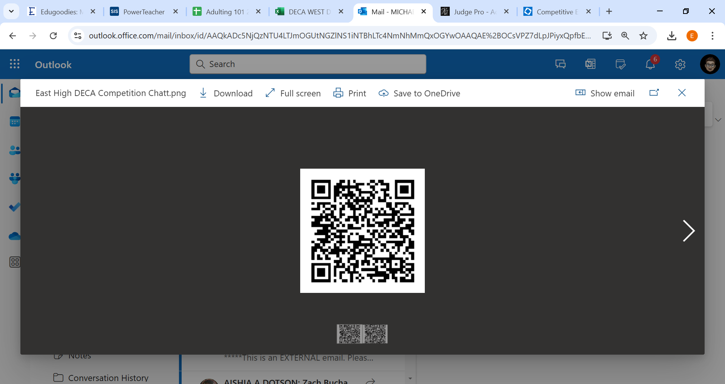

LINK TO MEMPHIS EAST HIGH DECA WEBAPAGE
https://schools.scsk12.org/Page/26518#calendar73027/20250131/month

